Christmas Tree Switch On
Friday 28th November 2025 @ 6PM

Billinge Parish Council and Billinge Residents Group
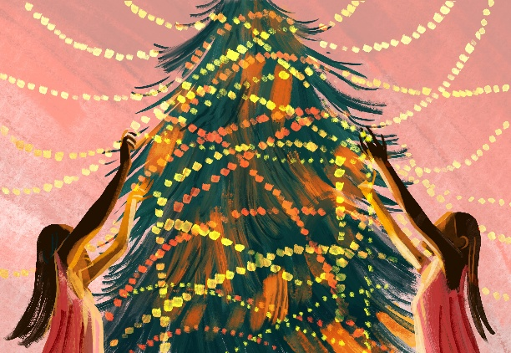
Invite
to the Christmas tree lighting
In The Millennium Garden
Main Street
Billinge

Special Guest – Santa Clause
Refreshments will be served in the public hall afterwards.

